Diagram | Main purpose | What it shows
Use Case Diagram | Identify functional requirements | Actors and their interactions with the system
Activity Diagram | Model workflows/processes | Sequence of activities, decisions, and parallel processes
Data Flow Diagram (DFD) | Model data movement | Processes, data stores, external entities, and data flows
Class Diagram | Model system structure | Classes, attributes, methods, and relationships
Sequence Diagram | Model interactions over time | Messages exchanged between actors/objects
State Machine Diagram | Model system behavior | States and transitions caused by events
Context Diagram | Define system boundary | System, external entities, and major information flows
Entity Relationship Diagram (ERD) | Analyze data requirements | Entities, attributes, and relationships
Component Diagram | Show high-level system components | Components and their dependencies
Deployment Diagram | Analyze deployment requirements | Hardware nodes, software components, and connections

Use Case Diagram
A Use Case Diagram is one of the most important UML diagrams used during requirements analysis. It provides a high level view of what a system should do from the perspective of its users or external systems.
The key idea is: A use case diagram describes the functional requirements of a system by showing who interacts with the system and what they want to accomplish.
1. What is a Use Case?
A use case represents a specific goal that an actor wants to achieve by interacting with the system.
For example, in a Library Management System:
- Search Book
- Borrow Book
- Return Book
- Reserve Book
- Pay Fine
- Add Book
- Remove Book
Each of these represents a use case. A use case should generally represent something meaningful that the user wants to accomplish, rather than a small internal operation.
Good use case | Poor use cases
Borrow Book | Click Button  Validate Password  Open Database Connection

2. What is an Actor?
An actor is an external entity that interacts with the system.
An actor can be:
- A human user
- Another software system
- A hardware device
- An organization or external service

For a library system: | For an online banking system: | For a hospital system:
- Student  - Librarian  - Administrator | - Customer  - Bank Employee  - Payment Gateway  - Authentication Service | - Patient  - Doctor  - Nurse  - Receptionist  - Insurance System

Important point: An actor is not necessarily a person.
For example:
Customer ─────── Online Banking System ─────── Payment Gateway
Actor System Actor
The Payment Gateway can be an actor because it is an external system interacting with the system under consideration.
3. Main Components of a Use Case Diagram
There are four major elements you should know:
- Actor
- Use Case
- System Boundary
- Relationship
The major relationships are:
- Association
- <<include>>
- <<extend>>
- Generalization

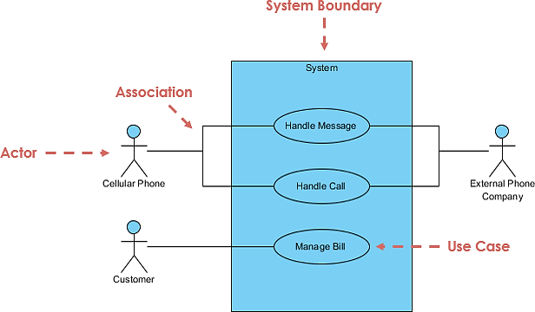
Notation Description | Visual Representation
Actor
- Someone interacts with use case (system function).
- Named by noun.
- Actor plays a role in the business
- Similar to the concept of user, but a user can play different roles
- For example:
  - A prof. can be instructor and also researcher
  - plays 2 roles with two systems
- Actor triggers use case(s).
- Actor has a responsibility toward the system (inputs), and Actor has expectations from the system (outputs).

Use Case  - System function (process - automated or manual)  - Named by verb + Noun (or Noun Phrase).  - i.e. Do something  - Each Actor must be linked to a use case, while some use cases may not be linked to actors. | 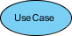
Communication Link
- The participation of an actor in a use case is shown by connecting an actor to a use case by a solid link.
- Actors may be connected to use cases by associations, indicating that the actor and the use case communicate with one another using messages.

Boundary of system  - The system boundary is potentially the entire system as defined in the requirements document.  - For large and complex systems, each module may be the system boundary.  - For example, for an ERP system for an organization, each of the modules such as personnel, payroll, accounting, etc.  - can form a system boundary for use cases specific to each of these business functions.  - The entire system can span all these modules depicting the overall system boundary | 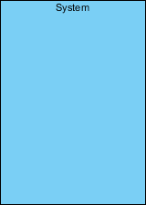
Use Case Relationship
Relationship | Meaning | Example
Extend | Indicates that one use case optionally or conditionally adds behavior to a base use case. The base use case can normally execute without the extending use case. | Invalid Password <<extend>> Login Account  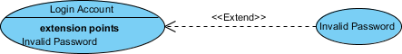
Include | Indicates that a base use case always uses the functionality of another use case as part of its process. It is useful for reusing common behavior. | Login Account <<include>> Validate Credentials  
Generalization | Represents a parent-child relationship. The child use case is a specialized or enhanced version of the parent use case. | Make Payment → Online Payment

Use Case Examples
Use Case Example - Association Link
A Use Case diagram illustrates a set of use cases for a system, i.e. the actors and the relationships between the actors and use cases.
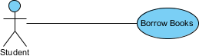
Use Case Example - Include Relationship
The include relationship adds additional functionality not specified in the base use case. The <<Include>> relationship is used to include common behavior from an included use case into a base use case to support the reuse of common behavior.
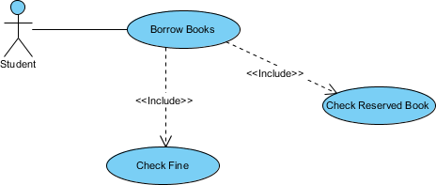
Use Case Example - Extend Relationship
The extend relationships are important because they show optional functionality or system behavior. The <<extend>> relationship is used to include optional behavior from an extending use case in an extended use case. Take a look at the use case diagram example below. It shows an extend connector and an extension point "Search".
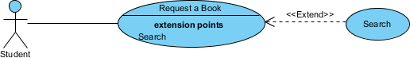
Use Case Example - Generalization Relationship
A generalization relationship means that a child use case inherits the behavior and meaning of the parent use case. The child may add or override the behavior of the parent. The figure below provides a use case example by showing two generalization connectors that connect between the three use cases.
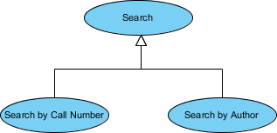

Use Case Diagram - Vehicle Sales Systems
The figure below shows a use case diagram example for a vehicle system. As you can see even a system as big as a vehicle sales system contains not more than 10 use cases! That's the beauty of use case modeling.
The use case model also shows the use of extend and include. Besides, there are associations that connect between actors and use cases.
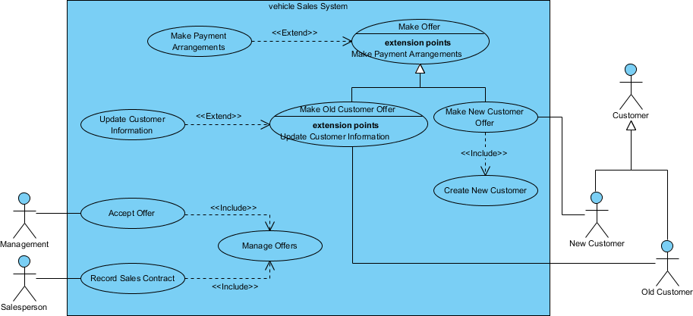
How to Identify Actor
Often, people find it easiest to start the requirements elicitation process by identifying the actors. The following questions can help you identify the actors of your system (Schneider and Winters - 1998):
- Who uses the system?
- Who installs the system?
- Who starts up the system?
- Who maintains the system?
- Who shuts down the system?
- What other systems use this system?
- Who gets information from this system?
- Who provides information to the system?
- Does anything happen automatically at a present time?
How to Identify Use Cases?
Identifying the Use Cases, and then the scenario-based elicitation process carries on by asking what externally visible, observable value that each actor desires. The following questions can be asked to identify use cases, once your actors have been identified (Schneider and Winters - 1998):
- What functions will the actor want from the system?
- Does the system store information? What actors will create, read, update or delete this information?
- Does the system need to notify an actor about changes in the internal state?
- Are there any external events the system must know about? What actor informs the system of those events?
Use Case Diagram Tips
Now, check the tips below to see how to apply use case effectively in your software project.
- Always structure and organize the use case diagram from the perspective of actors.
- Use cases should start off simple and at the highest view possible. Only then can they be refined and detailed further.
- Use case diagrams are based upon functionality and thus should focus on the "what" and not the "how".
Use Case Levels of Details
Use case granularity refers to the way in which information is organized within use case specifications, and to some extent, the level of detail at which they are written. Achieving the right level of use case granularity eases communication between stakeholders and developers and improves project planning.

